EBS

How to Create an AWS EC2 Instance and Attach EBS to EC2 With Terraform?

What is EBS?
Amazon Elastic Block Store (EBS) is a cloud-based storage service provided by AWS that offers persistent block storage for Amazon EC2 instances.

What is Terraform?
Terraform is an Infrastructure As code (IAC) tool that uses declarative configurational language that is Hashicorp Configurational Language (HCL) to define and provision infrastructure on a different Cloud Platform.

What is EC2?
Amazon Elastic Compute Cloud (EC2) is a core service offered by AWS that provides scalable computing capacity in the cloud. It allows users to run virtual servers, known as instances, on-demand, making it easier to deploy and manage applications without the need for physical hardware.

Steps To Create AWS EC2 Instance and Attach EBS To EC2 Using Terraform: -

What is Terraform Provider Block?

In Terraform, a “provider block” is a configuration block used to define the specific provider and its settings that Terraform will use to manage and interact with infrastructure resources.

Step 1: Mention the provider and region in which you want to create the AWS resources in provider.tf file.

CODE:

provider "aws" {

region = "us-east-1"

}

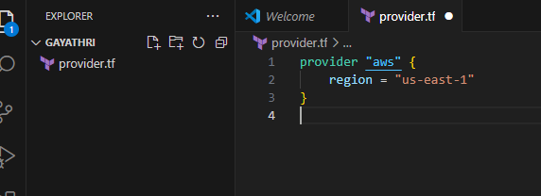

What is Terraform Variable Block?

A variable block defines variables that can be used in a Terraform configuration.

Variables are used to provide values that may change depending on the environment.

Step2: create a variables file where you have to mention all the variables that is EC2 instance going to use such as ami-id, instance type, server port, ssh port in variables.tf file.

CODE:

variable "ami_id" {

description = "This describes the ami image"

type = string

default = "ami-01c647eace872fc02"

}

variable "server_port" {

description = "Server use this port for http requests"

type = number

default = 80

}

variable "ssh_port" {

description = "Describes the ssh port"

type = number

default = 22

}

variable "availability_zone" {

default = "us-east-1a"

}

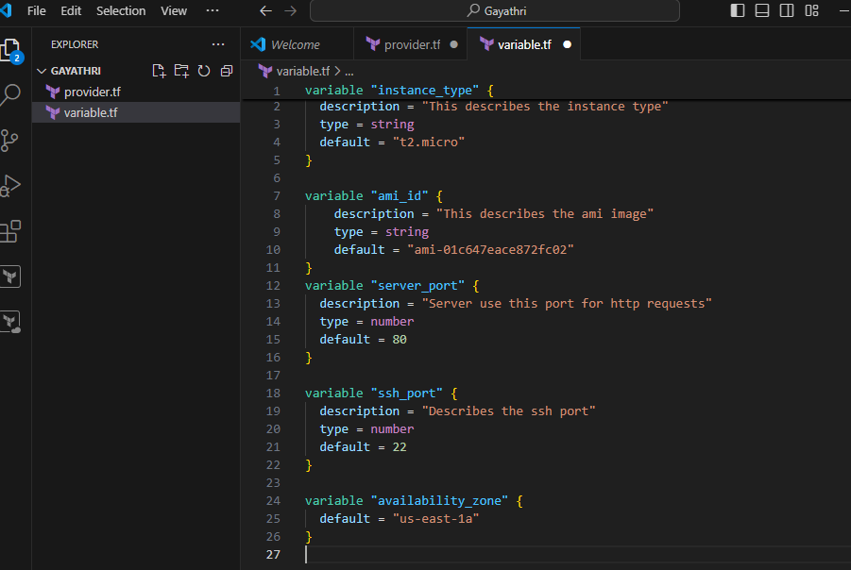

What is Terraform Main Block?

In Terraform, the main block typically refers to the main configuration file, usually named main.tf.

Step 3: Then create AWS instance resource. Here mentions the variables and also in the user data write a script that will install httpd service and index.html on the EC2 instance in main.tf terraform file.

CODE:

resource "aws_instance" "server" {

ami = var.ami_id

instance_type = var.instance_type

vpc_security_group_ids = [ aws_security_group.instance.id ]

availability_zone = var.availability_zone

tags = {

Name = "EC2-Server"

}

user_data = <<-EOF

#!/bin/bash

sudo yum update -y

sudo yum install httpd -y

sudo systemctl start httpd

sudo systemctl enable httpd

echo "Terraform is easy!!!" > /var/www/html/index.html

EOF

user_data_replace_on_change = true

}
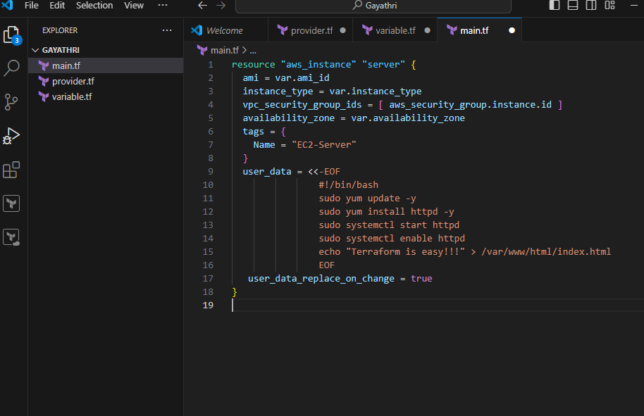

What is Terraform Output Block?

An output block is used to define output values that are generated by the Terraform configuration. It includes the output name and value.

Step 4: Create a output file which will give the public id of the EC2 instance as output in output.tf terraform file.

CODE:

output "public_ip" {

description = "The public IP address of the web server"

value = aws_instance.server.public_ip

}

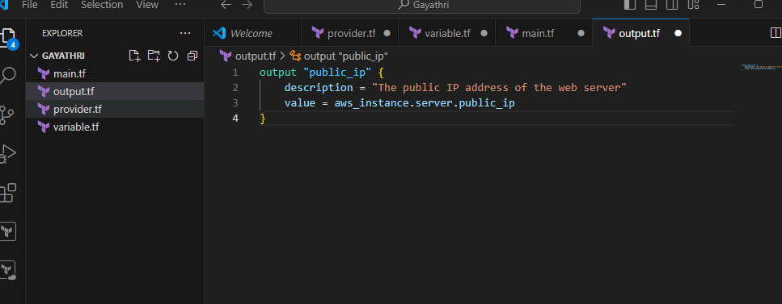

What is terraform security group block?

In Terraform, a security group is a resource used to control inbound and outbound traffic to AWS resources, primarily EC2 instances.

Step 5: Then create a file where you can define the security group configurations in security_group.tf file.

CODE:

resource "aws_security_group" "instance" {

name = "terraform-SG"

ingress {

from_port = var.server_port

to_port = var.server_port

protocol = "tcp"

cidr_blocks = ["0.0.0.0/0"]

}

ingress {

from_port = var.ssh_port

to_port = var.ssh_port

protocol = "tcp"

cidr_blocks = ["0.0.0.0/0"]

}

egress {

from_port = 0

to_port = 0

protocol = "-1"

cidr_blocks = ["0.0.0.0/0"]

}

}

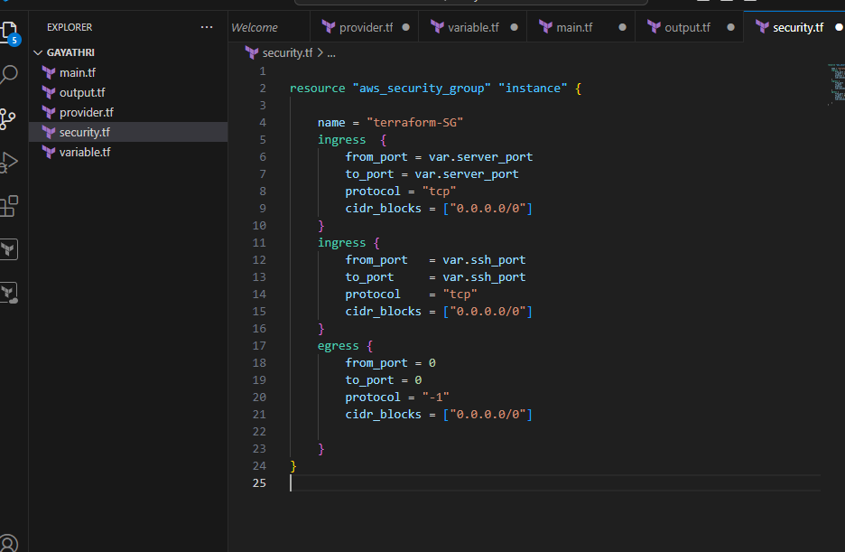

What is terraform EBS block?

In Terraform, an EBS (Elastic Block Store) block refers to the AWS EBS volume resource that you can manage using Terraform configuration files.
Step 6: Create an EBS volume. Then attach it to the EC2 instance in ebs_volume.tf file.
CODE:
resource "aws_volume_attachment" "ebs_att" {
device_name = "/dev/sdh"
volume_id = aws_ebs_volume.ebs_vol.id
instance_id = aws_instance.server.id
}
resource "aws_ebs_volume" "ebs_vol" {
availability_zone = var.availability_zone
size = 1
}
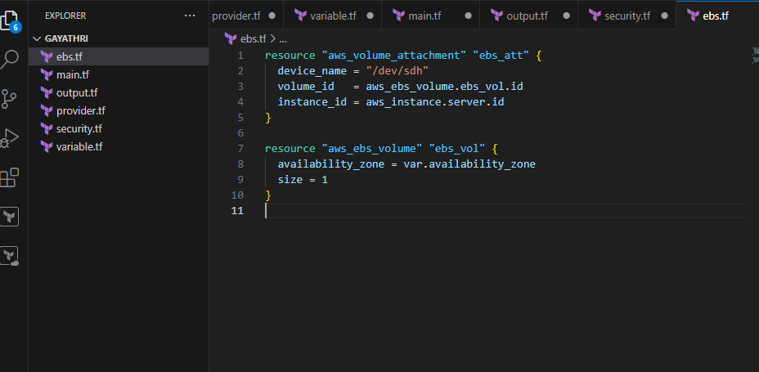

Step 7: Then run all the terraform files using the below commands one by one.
terraform init: terraform init is the command used to initialize a Terraform working directory.
terraform init
terraform validate: terraform validate is a command used to check the syntax and validity of your Terraform configuration files.
terraform validate
terraform plan: terraform plan is a command used in Terraform to create an execution plan.

terraform plan

terraform apply: terraform apply is a command used to apply the changes required to reach the desired state of your infrastructure, as defined in your Terraform configuration files.
terraform apply

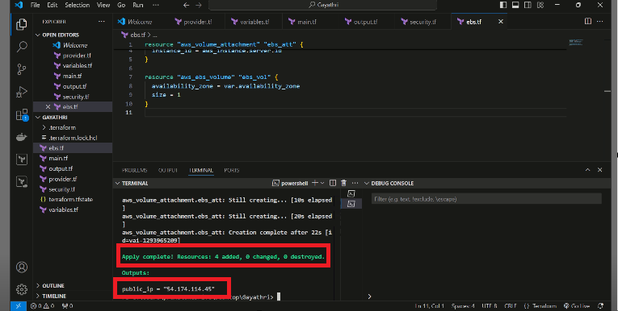

Step 8: Check on AWS console whether the EBS volume is attached to the EC2 instance or not.
Step 9: Then connect the public IP to see the website.

